Asia-China-Mirrors- Western Han dynasty (206 B.C.E.–8 C.E.)-

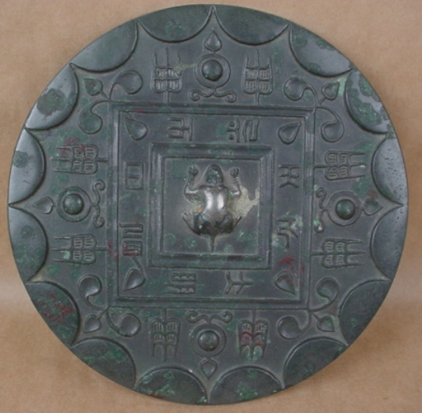

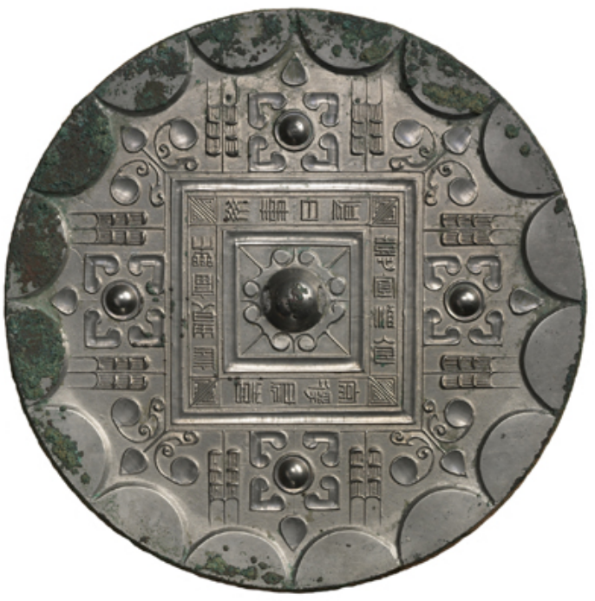

The earliest inscribed mirror in the Cotsen collection is from the Western Han dynasty (206 B.C.E.–8 C.E.). Within a design that embodies the cosmic principles of space, time, heaven, and earth, the inscription reads:

*May you enjoy noble status and  
blessings for a long time;  
May you have pleasure without incident;  
May you have delight every day;  
May you have plentiful wine and food;  
And may you regularly obtain lordly delights.*

*Mirror with Quatrefoil, Grass Motifs, Stars, and Linked Arc  
Western Han dynasty (206 B.C.E.–8 C.E.)*